📄 Test Case: TC59_InwardLodgeBill
❌ FAILED:
[2026-03-11 12:02:59] ? Exception Occurred: Expected condition failed: waiting for presence of element located by: By.id: billDate_ui (tried for 10 second(s) with 500 milliseconds interval)
↳ Reason: ❌ ❌ Exception Occurred: Expected condition failed: waiting for presence of element located by: By.id: billDate_ui (tried for 10 second(s) with 500 milliseconds interval)

📸 Screenshot:
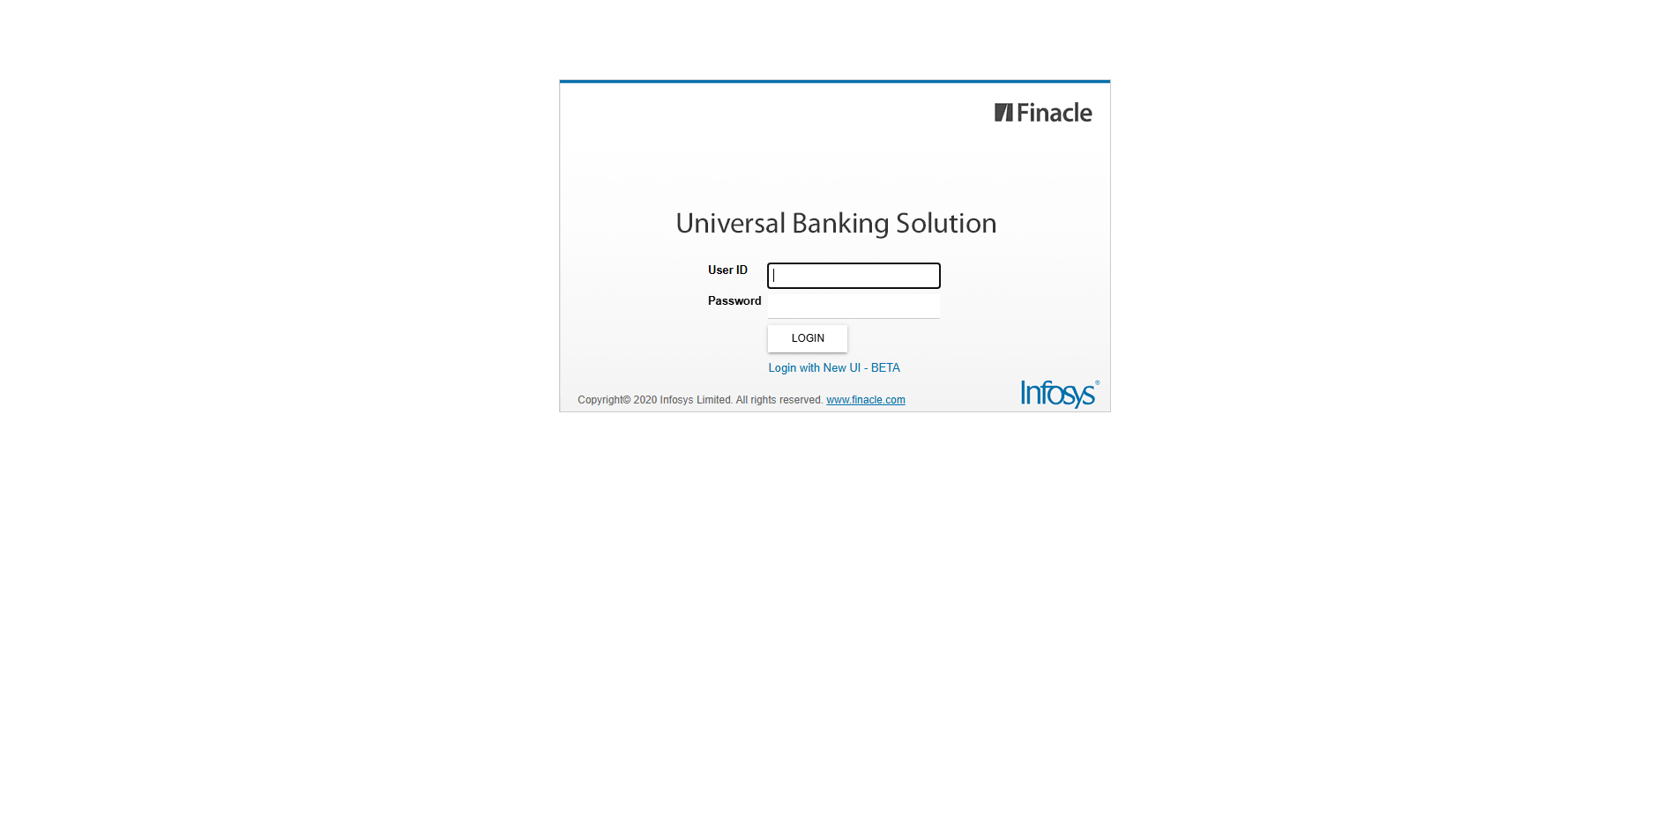
📄 Test Case: TC60_ModifyTheLodgeBillWhichIscreated
❌ FAILED:
[2026-03-11 12:04:28] ? Error: Tenor Details
[2026-03-11 12:04:28] ? Assertion Failure: Test failed: Tenor Details
↳ Reason: ❌ ❌ Assertion Failure: Test failed: Tenor Details

📸 Screenshot:

📄 Test Case: TC61_CanceltheModifiedInwardBill
❌ FAILED:
[2026-03-11 12:05:16] ? Login Failed: User is already logged in.
[2026-03-11 12:05:16] ? Assertion Failure: Finacle Login Error: User is already logged in.
↳ Reason: ❌ ❌ Assertion Failure: Finacle Login Error: User is already logged in.

📸 Screenshot:
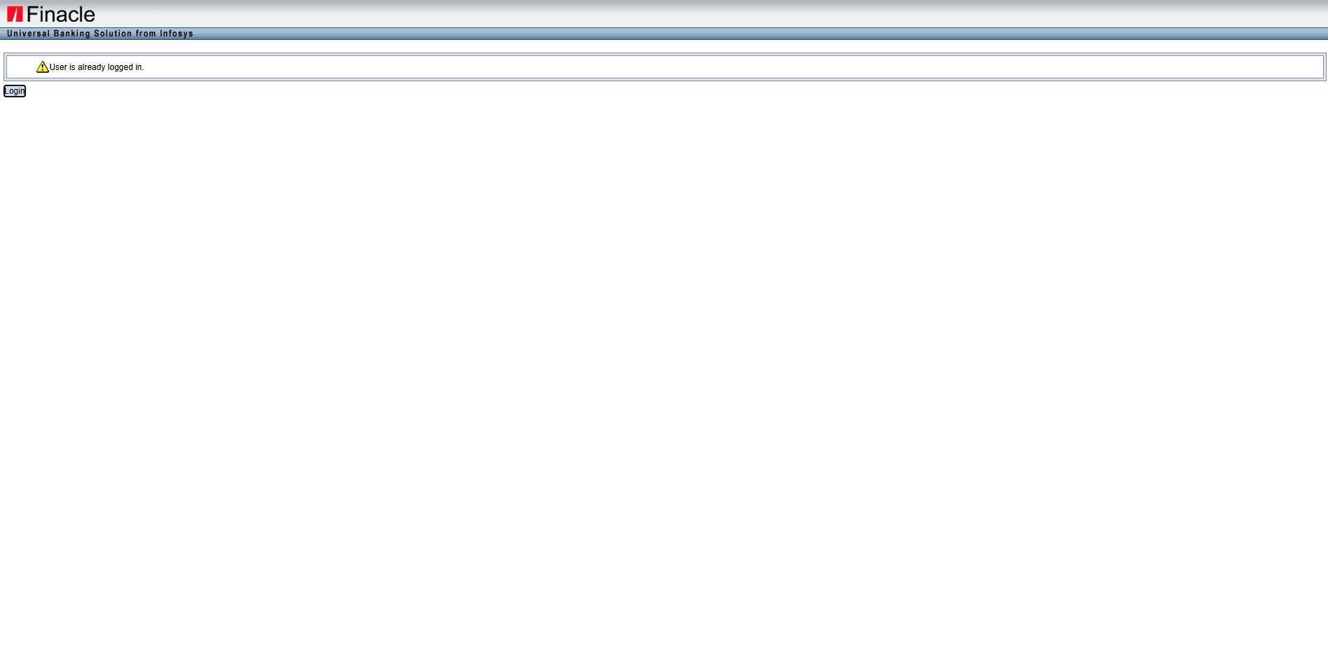
📄 Test Case: TC62_AmendTheInwardBillWhichIsLodge
❌ FAILED:
[2026-03-11 12:07:22] errorMsg = C22 - The previous process is not yet verified.
[2026-03-11 12:07:22] LabelText: null
[2026-03-11 12:07:22] BillID: null
[2026-03-11 12:07:22] ? Error: C22 - The previous process is not yet verified.
[2026-03-11 12:07:22] ? Assertion Failure: Test failed: C22 - The previous process is not yet verified.
↳ Reason: ❌ ❌ Assertion Failure: Test failed: C22 - The previous process is not yet verified.

📸 Screenshot:

📄 Test Case: TC63_DishonorOfInwardBillWhichIsAmended
❌ FAILED:
[2026-03-11 12:08:21] ? Error: E4221 - The bill ID cannot be dishonored. Bill Status: [Delinked]
[2026-03-11 12:08:21] ? Assertion Failure: Test failed: E4221 - The bill ID cannot be dishonored. Bill Status: [Delinked]
↳ Reason: ❌ ❌ Assertion Failure: Test failed: E4221 - The bill ID cannot be dishonored. Bill Status: [Delinked]

📸 Screenshot:

📄 Test Case: TC64_InquireTheInwardBill
❌ FAILED:
[2026-03-11 12:09:10] ? Assertion Failure: Exception occurred: Expected condition failed: waiting for presence of element located by: By.xpath: //td[contains(normalize-space(text()),'Bill Type')]/following-sibling::td[@class='textfielddisplaylabel'] (tried for 10 second(s) with 500 milliseconds interval)
↳ Reason: ❌ Exception occurred: Expected condition failed: waiting for presence of element located by: By.xpath: //td[contains(normalize-space(text()),'Bill Type')]/following-sibling::td[@class='textfielddisplaylabel'] (tried for 10 second(s) with 500 milliseconds interval)

📸 Screenshot:

📄 Test Case: TC65_ProtestTheInwardBillWhichIsDishonoured
❌ FAILED:
[2026-03-11 12:10:07] ? Error: E4221 - Liablity Exists, Recovery Event should be performed before Protest.
[2026-03-11 12:10:07] ? Assertion Failure: Test failed: E4221 - Liablity Exists, Recovery Event should be performed before Protest.
↳ Reason: ❌ ❌ Assertion Failure: Test failed: E4221 - Liablity Exists, Recovery Event should be performed before Protest.

📸 Screenshot:

============================================================
📊 Suite Summary: MIIBTests
===============================================
MIIBTests
Total tests run: 7, Passes: 0, Failures: 7, Skips: 0
===============================================
⏱️ Total Duration: 07 min 56 sec

